INSY6212 MOCK EXAM
ASSESSMENT TYPE: MOCK EXAMINATION (PAPER ONLY)
TOTAL MARK ALLOCATION: 60 MARKS
TOTAL HOURS: 1 HOUR AND 30 MINUTES (+10 minutes reading time)

Question 1 (Marks: 37)
Answer all the questions.

1.1. A project is known to be constrained by several factors or elements. State any three factors that could affect the successful completion of a project. (6)
1.2. You are presented with the two projects below, Project A and Project B. Study the presented project evaluation and selection then answer the question that follows:

PROJECT EVALUATION AND SELECTION
Criteria | Project A | Project B
Cost | R800 | R150000
Return on Investment | 6.1% | 12.4%
Time to market | 9 months | 12 months
Risk factor | High | Medium
Chances of success | High | High

When choosing between the two projects above, list the four project selection steps to follow. (4)
1.3. State four attributes of a project. (4)
1.4. Explain what a Request for Proposal (RFP) is and state who prepares it. (3)
1.5. Just because the contractor has been selected as the winner does not mean that the
contractor can start doing the work. Before the project can proceed, a contract must be signed between the customer and the contractor. Explain what a contract is and give two types of contracts. (6)
1.6. Differentiate between resource smoothing and resource-limited scheduling. (4)
1.7. Explain the purpose of a project charter and give at least six examples of elements that could be included in a project charter. (10)

Question 2 (Marks: 23 )
Answer all the questions.

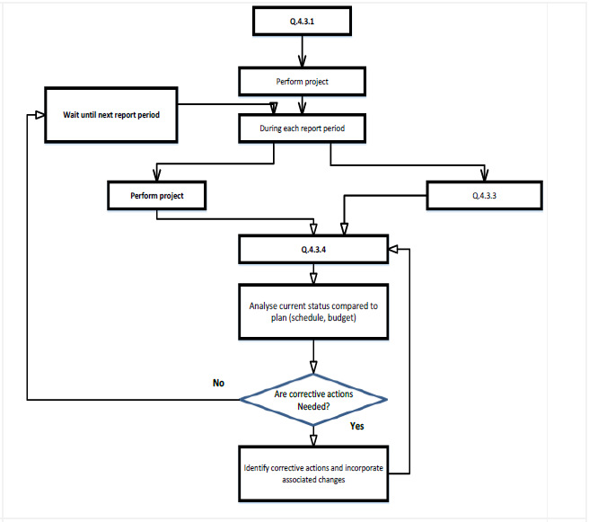
Collect data on actual performance
C
B
A

2.1. Study the diagram above and complete it regarding the project control process by
providing the missing steps in the process. (3)

2.2. Consider the network diagram below and answer the questions that follow:
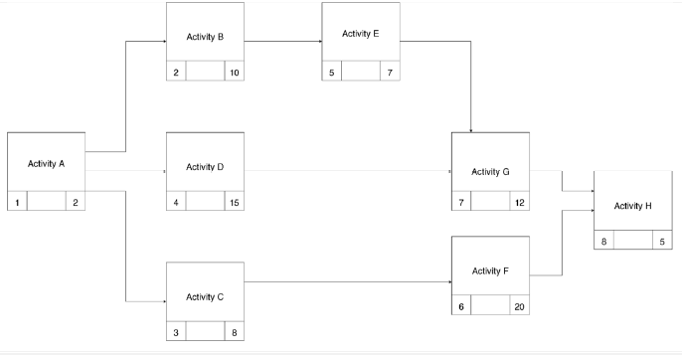
Calculate the Earliest Start, Earliest Finish, Latest Start, and Latest Finish times for each activity, and total slack time for each activity. Tabulate your answer (20)



